Linux - Unix Shell Programming Lab Programs —---------------------------------------------------------------------------------------------

B1. Write a C program that creates a child process to read commands from the standard input and execute them (a minimal implementation of a shell – like program). You can assume that no arguments will be passed to the commands to be executed.

B1.ChildProcess.c

#include<stdio.h>
#include<unistd.h>
#include<stdlib.h>
#include<string.h>
int main()
{
int pid,status;
char comd[20];
pid=fork();
if( pid == 0 )
{
printf("Child process\n");
while( strcmp(comd,"exit")!= 0 )
{
printf("[user@localhost~]$");
gets(comd);
system(comd);
}
exit(0);
}
else
{
wait(&status);
printf("parent process\n");
}
}

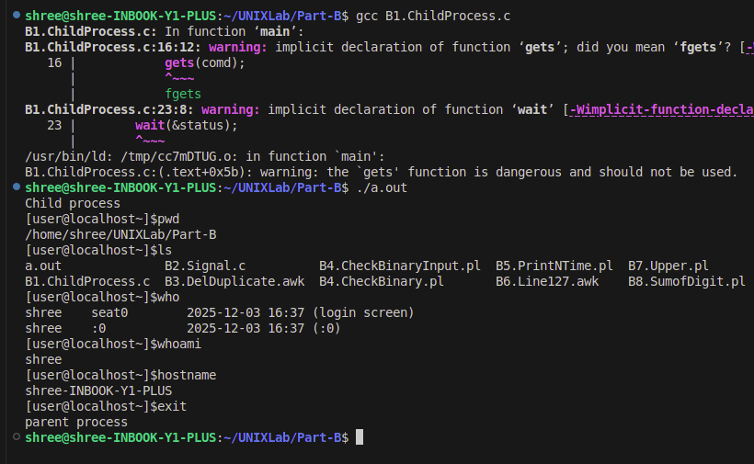

B2. Write a C Program to register a signal handler for SIGINT and when it receives the signal, the program should print some information about the origin of the signal.

B2.Signal.c

#include<stdio.h>
#include<signal.h>
void sig_handler(int signo)
{
printf("Signal caught is %d\t",signo);
}

int main(void)
{
(void) signal(SIGINT,sig_handler);
while(1)
{
printf("Hello world\n");
sleep(1);
}
return 0;
}

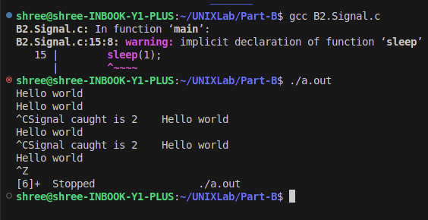

B3. Design an Awk script to delete duplicated lines from a text file. The order of the original must remain unchanged.

B3.DelDuplicate.awk

BEGIN{
n=1
}
{
a[n++]=$0
}
END{
for(i=1;i<n;i++)
{
flag=1
for(j=1;j<i;j++)
if(a[i]==a[j])
flag=0;
if(flag==1)
printf("%s \n",a[i])
}
}

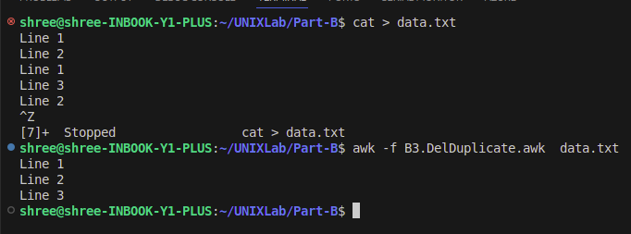

B4. Implement a PERL script that takes file as an argument, checks whether file exists and prints binary if file is binary.

B4.CheckBinaryInput.pl

#!/usr/bin/perl
printf("Enter the Filename:");
chop($f=<STDIN>);

if(-e $f)
{
if(-B $f)
{
printf("$f is a BINARY FILE \n");
}
else
{
printf("$f is NOT a Binary File \n");
}
}
else
{
printf("$f doesn't Exist\n");
}

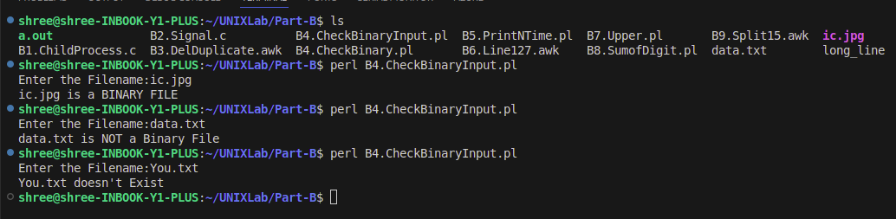

Method 2 :
B4.CheckBinary.pl
foreach $f (@ARGV)
{
if(-e $f)
{
if(-B $f)
{
printf("$f is a BINARY FILE \n");
}
else
{
printf("$f is NOT a Binary File \n");
}
}
else
{
printf("$f doesn't Exist \n");
}
}

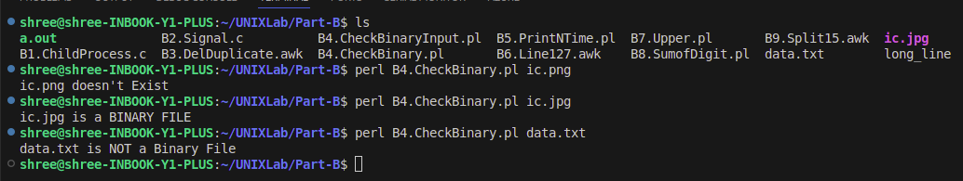

B5. Prompt user to input the string and a number, and prints the string that many times, with each string on separate lines using PERL script.

B5.PrintNTime.pl

#!/usr/bin/perl
printf("Enter the String:");
$a=<STDIN>;
printf("Number of times it should be displayed:");
chop($b=<STDIN>);
$c=$a x $b;
printf("Result is: \n$c");

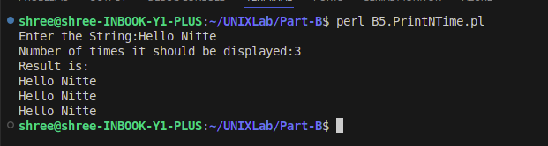

B6. Design an Awk program to provide extra symbol (i.e. * or @) at the end of the line (if required) so that the line length is maintained as 127.

B6.Line127.awk

{
y = 127 - length($0)
printf($0);
if (y > 0 )
for(i = 0;i < y; i++)
printf("*");
printf("\n");
}

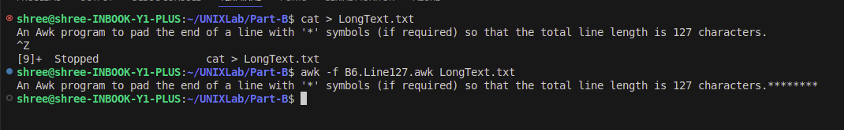

B7. Implement a PERL script that prints its command line argument, one per line after translating all lower-case letters to uppercase.

B7.Upper.pl

#!/usr/bin/perl
die("you have not entered the arguments\n")if(@ARGV==0);
foreach $arg(@ARGV)
{
$arg=~tr /a-z/A-Z/ ;
printf("$arg\n");
}

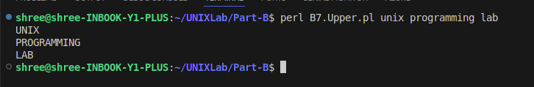

B8. Find the sum of digits of an unsigned number passed through argument using PERL.

B8.SumofDigit.pl

foreach $num (@ARGV)
{
$original_no=$num;
$sum=0;
until($num==0)
{
$digit=$num%10;
$sum=$sum+$digit;
$num=int($num/10);
}
printf("sum of digits of $original_no is $sum \n");
}

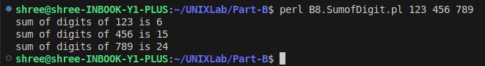
B9. Implement an Awk script that folds long lines into 15 columns. Thus, any line that exceeds 15 characters must be broken after 15th and is to be continued with the residue. The inputs to be supplied through a text file created by the user.

B9.Split15.awk

{
st = $0
while (length(st) > 15) {
print(substr(st, 1, 15) );
st = substr(st, 16)
}
print(st);
}

